THERA-PAW CUSTOM DEVICE REQUEST

If interested in a custom device, please complete this form and give it to your veterinary professional. Thank you.

I think my pet may benefit from a device provided by Thera-Paw, Inc.

I realize that this is a prescription item and requires the approval and cooperation of my veterinary professional. The product that I am interested in is (check below):

______Custom Carpal Support: customized for a variety of carpal conditions including:  hyperextension valgus or varus deformities collateral ligament injuries soft-tissue flexion contractures immune-mediated polyarthritis instabilities, sprains, strains fractures or post-cast removal protection/support of limb w/ osteosarcoma arthritis, DJD | 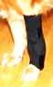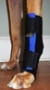
______Custom Tarsal Support: customized for a variety of tarsal conditions including:  Achilles/gastroc tendon injuries hyperextension collateral ligament injuries immune-mediated polyarthritis instabilities, sprains, strains  tarsal luxation fractures or post-cast removal arthritis, DJD, OCD | 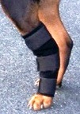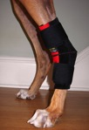
______Hindlimb Dorsi-Flex Assist: reduces dragging, knuckling, standing on the dorsum of the paw without immobilizing joints; customized for a variety of distal hindlimb conditions including:  early stage DM or Wobbler’s ataxia sciatic nerve injury  lumbosacral disease age-related weakness tarsal hyperextension | 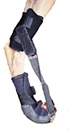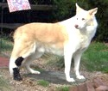
______Forelimb Dorsi-Flex Assist reduces dragging, knuckling, standing on the dorsum of the paw; supports/stabilizes the carpus; customized for a variety of distal forelimb conditions including:  brachial plexus avulsion radial nerve injuries IVDD | 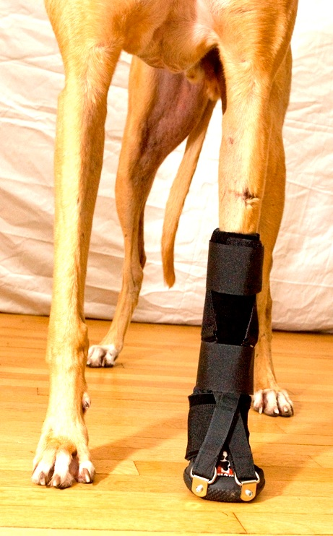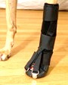
My Name:__________________________________________________

My Pet’s Name:_____________________________________________

Condition for which my pet needs this device:__________________________________________

My daytime phone number:________________________________________________________

-----------------------------------------------------------------
To the Veterinary Professional: Your client is interested in the above selected device. Please review this information with your client. If you feel that your client’s pet may benefit from the requested device, or if you have questions about our devices, please contact us at: 908-439-9139 or questions@therapaw.com. Thank you.

